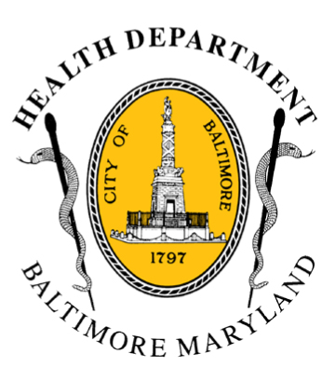
BCHD PRESS RELEASE
Baltimore City Health Department
1001 E. Fayette Street • Baltimore, Maryland 21202
Stephanie Rawlings-Blake, Mayor
Leana Wen, M.D., Commissioner of Health

FOR IMMEDIATE RELEASE
June 23, 2015

Media Contacts:
Michael Schwartzberg, PIO
O: (443) 984-2623 C: (443) 462-7939 E: michael.schwartzberg@baltimorecity.gov

Jennifer Fuson, Communications Specialist
O: (410) 545-0823 E: Jen.Fuson@baltimorecity.gov

14 Brands of Niagara Bottled Water Recalled For Possible E. Coli Contamination

Residents Should Be Alert of This Brand of Bottled Spring Water

BALTIMORE, MD (June 23, 2015) – Niagara Bottling is issuing a voluntary recall of 14 brands of bottled water products due to concerns of possible E. coli contamination from the spring source. Today’s heat index* is expected to reach 105 degrees, so residents drinking bottled water should be cautious of the brands involved in the recall.
The water was sold under the following brand names:

Acadia
Acme
Big Y
Best Yet
7-11
Niagara
Nature’s Place
Pricerite
Superchill
Morning Fresh
Shaws
Shoprite
Western Beef Blue
Wegman’s

“E. coli can be a very serious infection. Given the Code Red weather today, out of an abundance of caution, we want to alert residents drinking bottled water of the voluntary recall,” said Baltimore City Health Commissioner Dr. Leana Wen. “Please continue to hydrate yourself and drink plenty of fluids. If you are drinking bottled water, note the brand and codes involved in the recall and avoid those bottles.”

The Niagara Bottling products were produced at both the Hamburg, PA and Allentown, PA facilities from the time frame of 3am (EDT) June 10th to 8pm (EDT) June 18, 2015. To determine if your product is affected, Niagara is recommending referencing the following information on the bottle’s code, which will indicate the place, date and time that the product was produced.
The only affected products have codes that begin with the letter F (for Hamburg) or A (for Allentown). The first digit after the letter indicates the number of the production line. The next two numbers indicate the day, then the month in letters, the year, and then the time, based on a 24-hour clock.
DO NOT DRINK THE AFFECTED WATER WITHOUT BOILING IT FIRST OR USE OTHER BOTTLED WATER. Bring all affected water to a boil, let it boil for one minute, and let it cool before using, or use other bottled water. Boiling kills bacteria and other organisms in the water.
For more information see Niagara’s website at: http://www.niagarawater.com/consumer-notice/

About E. coli:

The first symptom of E. coli infection is the onset of abdominal pain and severe cramps, followed within 24 hours by diarrhea, often bloody. This is hemorrhagic colitis, and it typically occurs within 2 to 5 days of ingestion of E. coli; however the incubation period—the time between the ingestion of E. coli bacteria and the onset of illness—may be as broad as 1 to 10 days. If you suspect infection, seek medical attention.

During periods of extreme heat, the Baltimore City Health Department recommends that city residents:

- Drink plenty of water and avoid alcohol and caffeine
- Reduce outside activities and stay inside in air-conditioned locations
- Never leave children or pets alone in closed vehicles, even for short periods of time
- Check on older, sick, or frail neighbors who may need help responding to the heat
- Watch out for signs of heat exhaustion and heat stroke, which include:
- Confusion
- Hot, dry, flushed skin or cool and clammy skin
- Lightheadedness
- Nausea
- Call 911 immediately if any of these symptoms occur

*The heat index is a measure of air temperature and relative humidity and indicates how hot it feels to individuals outside. This is the first Code Red of the season.
###

